Lactose
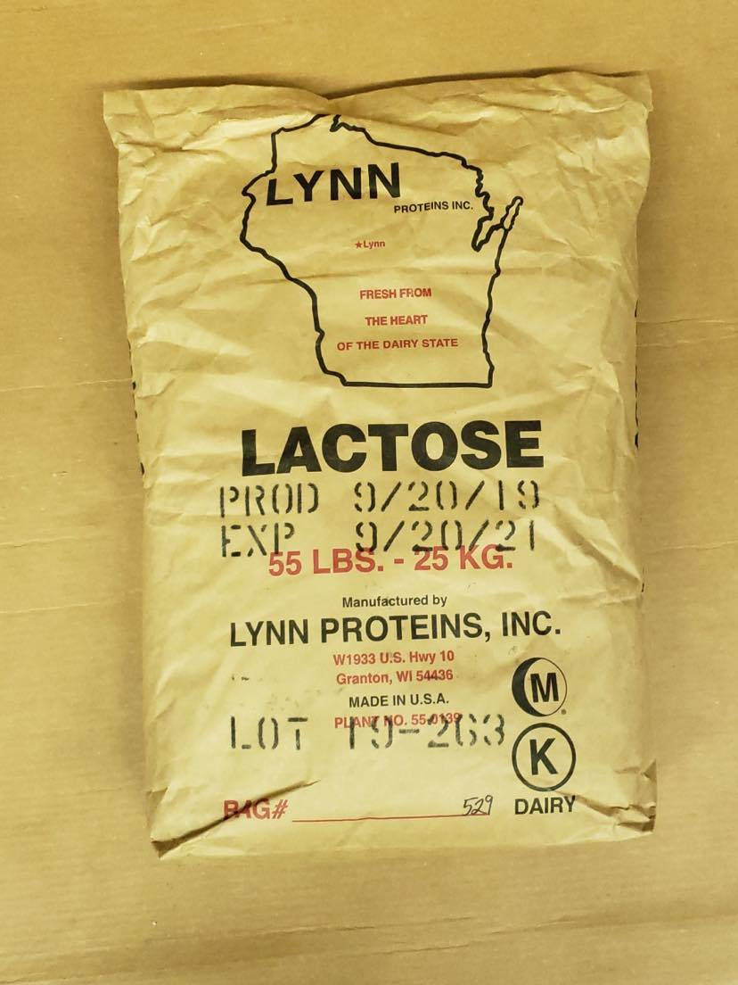
Gotham Product Code:

9876

Manufacturer Code:

GLM-LACT50

Pack Size:

55 lb Bag

