Riceland Rice Hulls
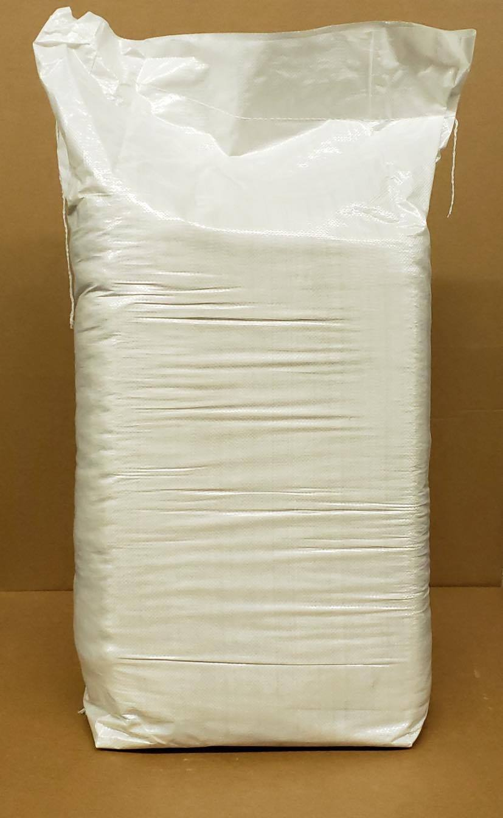
Gotham Product Code:

9882

Manufacturer Code:

GP-RICE

Pack Size:

50 lb Bag

